ENGLISH CLASS:
PAST TENSES

It was raining and people were walking on the street.
My mom was riding and i was singing
I was walking when i heard a cat
This morning i was wating for my train.
Last time we were eating pizza.

I was late this morning , because my train had been canceled.
When i came back home, i saw that my cat had broken my TV
I was tired so i went to bed and i slept

GRAMMAR
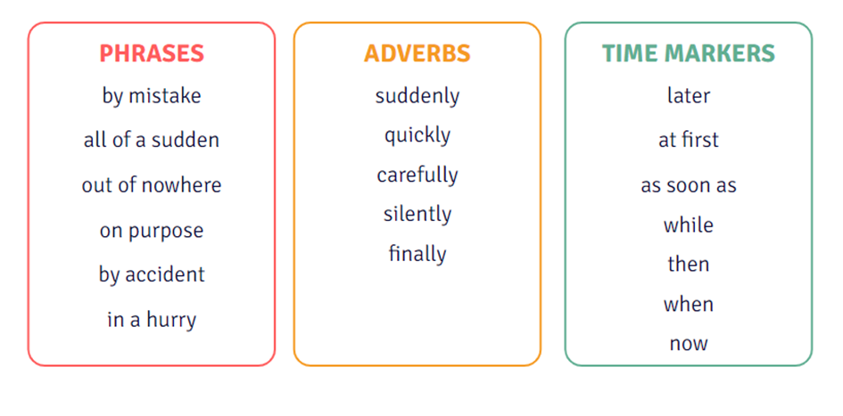

My experience at cesi
I’ve always been good at sciences in school, and I liked mathematics. In primary school what i prefered was being better at solving problems than everyone else, especially the boys. They were so angry about it. It was like a game between us.
When I grew up/ it became/gota bit boring, but it was still my favorite class. So it was clear for me that i would be studying sciences later.
While I was in school learnig my lessons for my baccalaureat i was using apps to organise myself my homework, my free time , etc
But none of these apps were exactly what I needed, so all of a sudden i got an idea! If i do it myself, it will meet all my expectations. Sadly I had not the skills to do it myself.
That’s how I knew I had to learn about informatic technologie. Then every time i wished something on my phone was better, I thought that I will learn how to do it.
For example, I really wanted to be aware as soon as possible when my trains were late or canceled. But the SNCF app was not able to. So, I remember saying to my mom, “When I will be an informatician, I’ll made a greater app who’ll help everyone!”
I was looking for an engineer school and I found CESI

